Alaska Indoor Gardening Curriculum

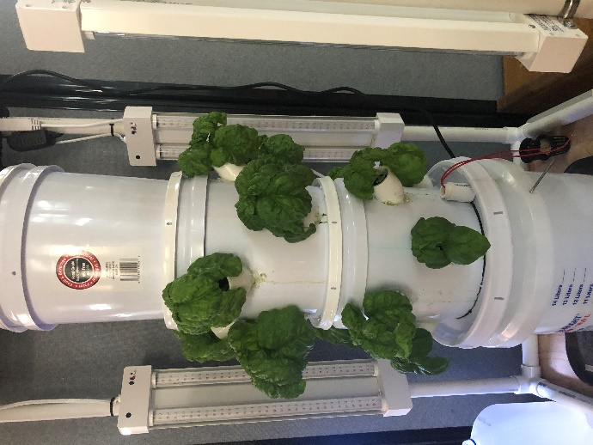
Using Your Small Hydroponic Grow Tower

Author/Source: Mel Sikes, Adam Low (design)

Suggested Grade Levels: Upper Elementary, Middle, High School
(Teachers can prep materials ahead of time.)

Time: Multiple class periods

Teaching Goal:
To introduce students to the fun of raising edible plants indoors using a vertical hydroponic growing system made with hardware store buckets.

Learning Objectives:
To explore the plant life cycle by building and operating a hydroponic grow tower.

Core Ideas:
- Hydroponic Systems
- Plant Dynamics (circulation and nutrient uptake)
- pH, Acidity, and Alkalinity Testing
- Standardized Science Measurements
- Drawing Conclusions from Experimentation (hands-on, observation, and note-taking)

Alaska State Science Standards: Science: 4-LS1-1, 4-PS3-4, 5-PS3-1, 5-LS1-1, 5-LS2-1, MS-LS2-1, MS-LS2-4, MS-LS2-5, MS-ESS3-3, MS-ETS1-4, HS-LS1-2, HS-LS2-5, HS-ESS3-4

NGSS Standards: 4-LS1-1, 5-PS3-1, 5-LS1-1, 3-5-ETS1-1, MS-LS1-5, MS-LS2-1, MS-ESS3-3, MS-ETS1-4, HS-LS1-3, HS-LS2-7, HS-ESS2-6, HS-ESS2-7, HS-ESS3-4, HS-ETS1-3

Materials Needed
- 1 fully constructed hydroponic grow tower
- 1 prepared light structure and extra zip ties
- Fertilizer
- Seeds
- Hydroponic grow media
- Water

Vocabulary:
- Hydroponics: is a method of growing plants in water without soil. The water must be enriched with nutrients and the plants need some type of inert medium to support the root system.
- Medium: substance or material in which something exists or grows, from the soils and other materials for plant growth.
- pH: stands for potential of hydrogen, which is a measurement of the hydrogen ion concentration in the water. Plants grow best in a slightly acidic pH range of 6 to 7.
- Acidity: the level of acid in substances such as water, or soil
- Alkalinity: the ability of water to neutralize acid or to absorb hydrogen ions.
- Algae: algae is an informal term for a large diverse group of photosynthetic organisms which are not necessarily closely related
- Roots: are a very important part of the plant, a roots four major functions are: absorption of water and inorganic nutrients, anchoring the plant, storage of food and nutrients and vegetative reproduction
- Oxygen: plants take in oxygen and give off carbon dioxide nutrients
- Nutrients: plants must obtain the following mineral nutrients for their growing medium they need nitrogen, phosphorus, potassium, calcium, sulfur, and magnesium

Background for Teachers:
The 'Do It Yourself' (DIY) Grow Tower Project is the brainchild of Alaskan entrepreneur Bernie Karl and Jake Scott. It is much more than just an experiment with vertical hydroponics, it is a concept meant to spark the curiosity of the youth all over the country - To help sow the seeds that will yield the next generation of farmers and food suppliers in America.

In order to cultivate a genuine passion for food production, one must first be introduced to it in a hands-on manner. That is the true purpose of the Lettuce Tower Project - An easy-to-build project that can get our youth involved in the construction and use of a hydroponic food production system.

This lesson plan is on how to use and maintain your grow tower. How to grow plants for the tower, set up the tower with the plants, and monitor and maintain the tower for continued use.

The opportunities for STEM with students are great with this project. Allow the students to explore options of modifying the design to maximize the efficiency of growth for the plants you choose to grow. Lights and the type of nutrients you use can be variable and worthy of experimentation. Also, you can explore the opportunities of automation and monitoring with easily available robotic devices such as Raspberry Pie boards (additional lessons are forthcoming).

Step 1: Attach two elbows to each of the 2 foot PVC Pipes. Make 2 squares.
Set Up the Light Structure

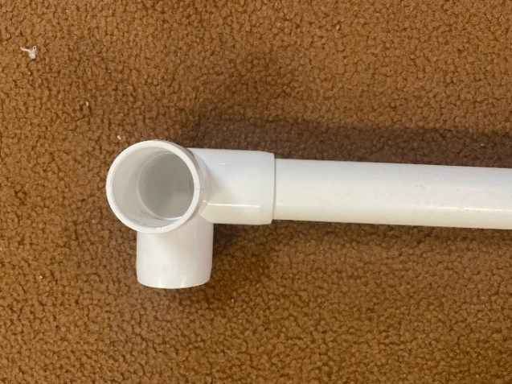
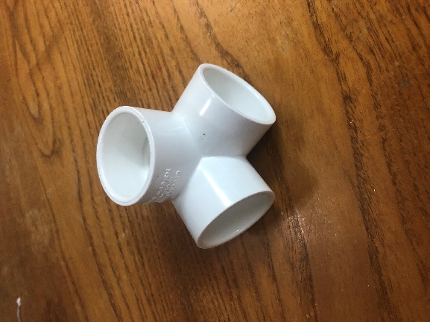

Step 2: Add a 4 ft pipe to each of the corner connectors.

Step 3: Add the top square and your structure should look like this:

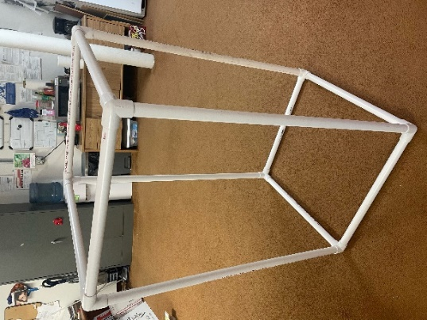

Step 4: Attach the lights to the 4-foot pipes with zip ties and the light holders that come with the lights. You can also screw them directly into the PVC with the screws that come with the lights.

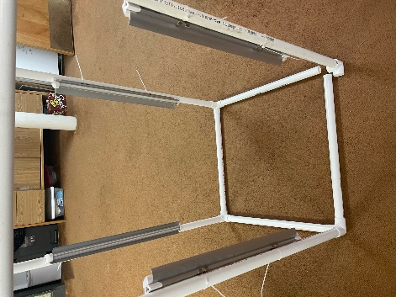
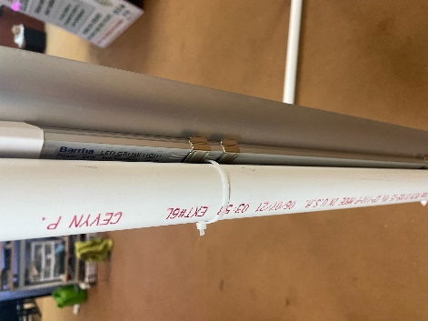
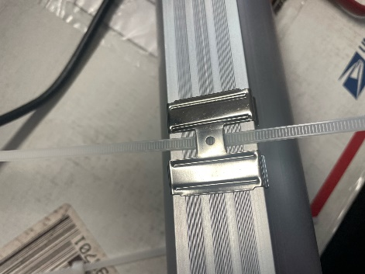

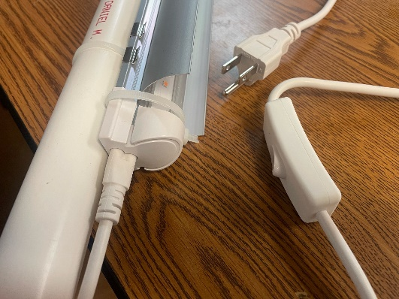
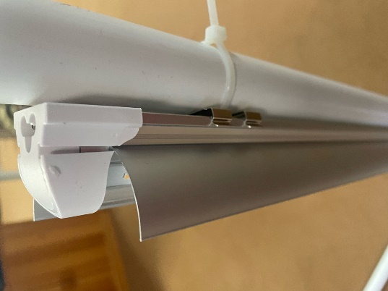
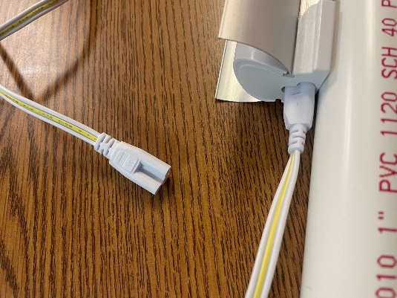
Step 5: Attach the plug cord to one of the lights at the bottom. Attach a connector cord to the top of that light and connect to the next light on the top. Attach another connector cord to the bottom of that light.

Crop Selection: The first choice to make is which crop you will grow in your tower as this will determine what type of fertilizer and potential lighting needed to get results. The Bucket Grow Tower was originally created with the intention of growing lettuce and this choice may be the easiest for beginners, but the possibilities are much greater. The tower can produce spinach, arugula, mustard greens, strawberries, several herbs and many other options.
Growing Plants in Your Tower

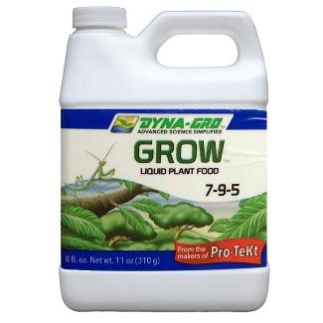
Fertilizer Selection: The fertilizer chosen should cater to the preference of the crop chosen. We recommend using a hydroponic fertilizer. Some fertilizer brands such as DynaGrow has proven itself to work well in the tower. If you can't find a fertilizer specifically designed for your crop just take to the internet to find out what levels of N-P-K in a fertilizer are right for your plant and find a general use N-P-K fertilizer at your local home & garden store that is close to the levels your plant desires. No matter what fertilizer product you choose, remember to always follow the mixing instructions on the package for best results.

Light: You WILL need lighting to get the results you want. Just placing the tower in a window is not enough for plants to grow well. If you choose to grow lettuce or other leafy greens in your tower, your lighting requirements will be minimal and can be satisfied by using inexpensive LED light tubes and fixtures available at any home improvement store. If you decide to tackle a bigger challenge and produce a flowering/fruiting crop in your tower, then you may need to invest in some horticultural grade grow lights to achieve the best results. Always research your crop beforehand so you understand what kind of
lights your plants need.

Choose Your Grow Media: The grow tower requires plants to be grown in an inert media that provides support for the stem and roots but gives no nutrients to the plants. Soil does not work because it will wash away and clog the pump. The two types of media that work best in the tower are Rockwool (1 ½”cubes) or Rapid Rooter peat plugs. Both come with a hole in the top for placing your seeds. It is best to wash the rock wool and the rooters before using.
Starting Your Seedlings
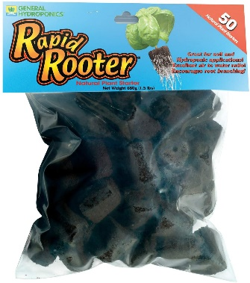
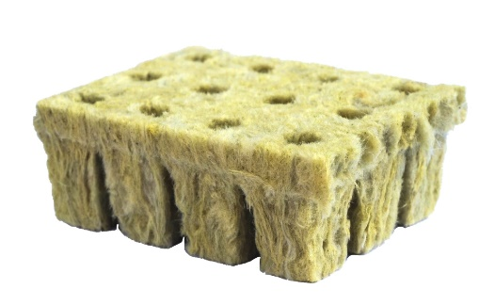

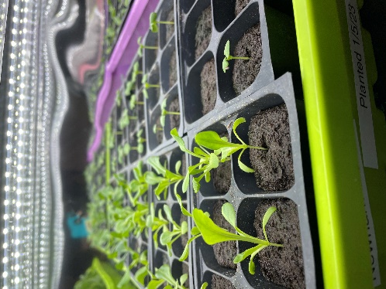
Starting Seedlings: Start your seeds in six pack containers and
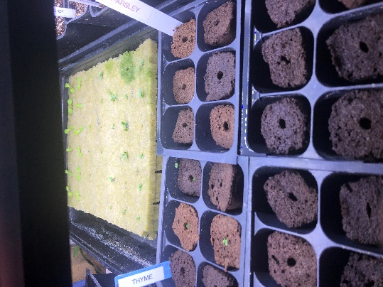
have them under lights on a shelf for 2-3 weeks before you intend to put them into your grow tower. It is a good idea to start more seedlings than will actually fit into your tower so you may pick the strongest most promising seedlings to transplant into the tower.
Place one to two seeds in each cube or plug. Plants should be grown on a shelf with lights at most 3” from the container they are grown in. If you don’t have a shelf, grow the plants on a plate on the top of the tower.

Watering the Seedlings: From planting the seed until transplanting into your tower, you may just water the media and seeds with regular, unfertilized water. Spray bottles are the best to assure you don’t over water. The cubes should be watered daily and kept consistently moist throughout the germination process.

Are they ready? About a week after your seedlings emerge begin checking the bottoms of the cubes daily. Once you can see little white roots starting to poke out of the bottom of the cubes or plugs and your second set of leaves have emerged, your seedlings are ready to go into your tower.

Prepare your tower: Mix the fertilizer of your choice according to the instructions on
Putting the Plants into the Tower
the fertilizer label and fill the base/reservoir of the tower with 3-4 gallons of this nutrient solution. Do NOT over fertilize, read the directions on the bottle.

If you are using Dyna Grow Fertilizer:
- When you add water to the tower initially, add 2-3 tsp of fertilizer per gallon.
- When you add water as the tower is going, reduce it to 1 tsp/gallon
- If you have too much algae in the water and it gets very green, replace all the water and treat it as you would as if you were starting the tower again.

Add the Plants: If using rockwool, break your rockwool cube sheet into individual cubes with one plant per cube. Nestle the plant cube or plug into a PVC elbow and gently push it down into the elbow with two fingers. Make sure it is at least ½ inch into the elbows so that the roots are underneath the three holes that were drilled. Be sure not to push them too far and lose them inside the tower.

Lights: Keep the lights on a timer. 12 hours on and 12 hours off is the
best schedule for leafy plants. Do not plug the pump into the
timer. The pump should be on all the time and plugged in separately.

Harvesting Your Plants: Plants do not need to be harvested all at once. You can use the
leaves as they grow. Pick lettuce leaves from the outside to
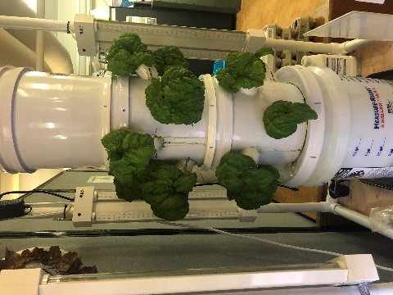
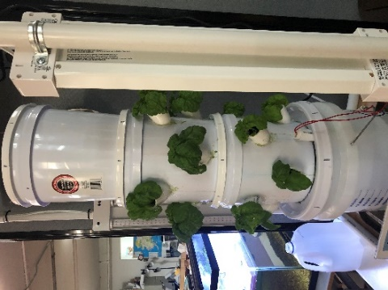
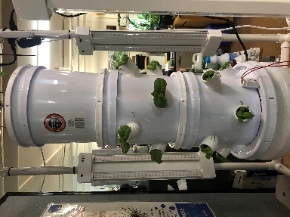
encourage continuing growth. Do not pick from the middle of lettuce Herbs should be picked so that you don’t remove all the leaves. The plants will sprout new leaves. Always remove any flowers on herbs.
Monitoring and Cleaning Instructions
- Monitor water levels every week and replace water as needed. If the pump is off, add water. Add nutrients to water according to directions on container, as necessary. READ the directions, don’t over fertilize!!!!! It’s important to reduce the fertilizer on water additions after the initial starting of the system to prevent nutrient buildup and overload.

- Monitor your plants. Watch leaves for any browning or yellowing. This will let you know if you have enough or too much nutrient in your water. Brown = too much nutrient. Yellow = Not enough! Adjust as needed. Visit https://www.youtube.com/watch?v=Webb1cjen6s or https://www.nosoilsolutions.com/common-issues-hydroponic-gardeners-face/ for suggestions on troubleshooting growing issues.

- Look for aphids or other critters on your leaves on a regular basis. Use a non-toxic pesticide such as neem or similar plant based solution for ridding the plants of the pests.

- If the pump doesn’t sound right, check the pump. Unscrew the PVC center pipe from the pump. Pull off the half of the pump that has the sponge looking black filter material on it. It should come off with a little tugging. There is a foam filter in there, wash out the plant material and put the pump back together and put back on the PVC pipe and back into the tower.

- Nutrient Change for Blooming Plants: If you are just doing leafy greens, choose a nutrient specific to growing leaves often labeled “grow”. If you are doing a plant with fruit such as tomatoes or peppers, you will need to change the nutrient once the plant reaches a the flowering stage (different with each type), often labeled “bloom”. You will need to hand pollinate the plants either with a paint brush or shaking it or a q-tip.

- Clean out the whole grow system at least every 4-6 months.

Algae
You WILL get algae in the tower. It’s normal and not a bad thing. You can wipe the tower with a paper towel to remove the algae. If you have too much algae in the water in the bottom bucket and the water gets very green, replace all the water and treat it as you would as if you were starting the tower again. Check out this website for more information about algae. https://plantprovider.com/managing-algae-in-hydroponic-systems-step-by-step/

Extensions: Suggested Lessons: Intro to Hydroponics, Hydroponic Plant Growth, Journaling lesson, Indoor Gardening, Passive Hydroponic System.

Assessment: Students can explain how the system works. Successful plant growth.

References
Books:
Gardening Indoors with Soil and Hydroponics
by George Van Patten 2007 ISBN: 978-1-878823-32-8

How to Hydroponics by Kenneth Roberto
ISBN: 0-9672026-1-2 2014

Hydroponic Basics: The Basics of Soilless Gardening Indoors
by George F. Van Patton 2004 ISBN: 978-1-878823-25-0

Hydroponics: A Complete DIY Guide for Gardening Using Simple Steps
by Allen Dunn 2012 ISBN: 9781480236141

Vertical Gardening: Grow Up, Not Out, For More Vegetables and Flowers in Much Less Space
by Derek Fell 2011 ISBN: 978-1-60529-083-6

Vertical Gardening for Beginners: How to Grow Organic Food at Home Without a Yard
by Peter Kingston 2016 ISBN: 9781532804823

Websites:
Chena Hot Springs Resort: https://chenahotsprings.com/vertical-bucket-grow-tower/

Foothill Hydroponics: http://www.foothillhydroponics.com/

General Hydroponics: http://generalhydroponics.com/

Hydroponics: https://hydroponics.com/

Institute of Simplified Hydroponics: http://carbon.org/

Simply Hydroponics and Organics: http://www.simplyhydro.com/system.htm

Uponics: http://uponics.com/hydroponic-tower/

